Azure Data Engineer: Batch 6

(October 2023)

**Submitted by: Roopmathi Gunna**

**On 7-Nov-2023**

Assignment 4: ADF Pipeline 1

**Pipeline 1:**

Go to the ADF studio and create your first pipeline name: Copy_ProductTable_To_CSV.

In the newly created SQL DB there is one built in SalesLt.Product table.

Copy the Product table data to CSV file in 'landing/CSV' folder in ADLS using the ADF.

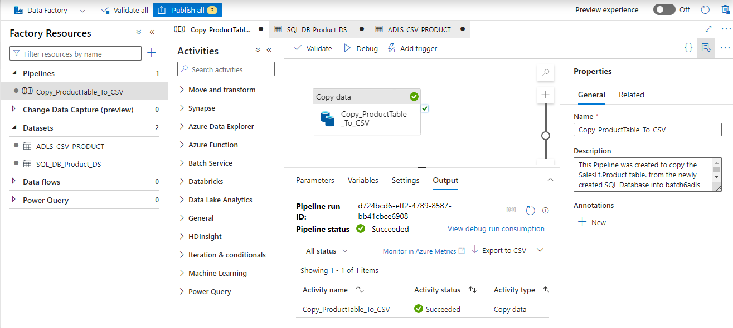

Pipeline 2:

Create another pipeline name: Copy_Customer_To_JSON In the newly created SQL DB there is one built in SalesLt.Customer table. Copy the Customer table data to JSON file in 'landing/JSON' folder in ADLS using the ADF. Hint: During the dataset creation step instead of choosing the file type CSV choose JSON

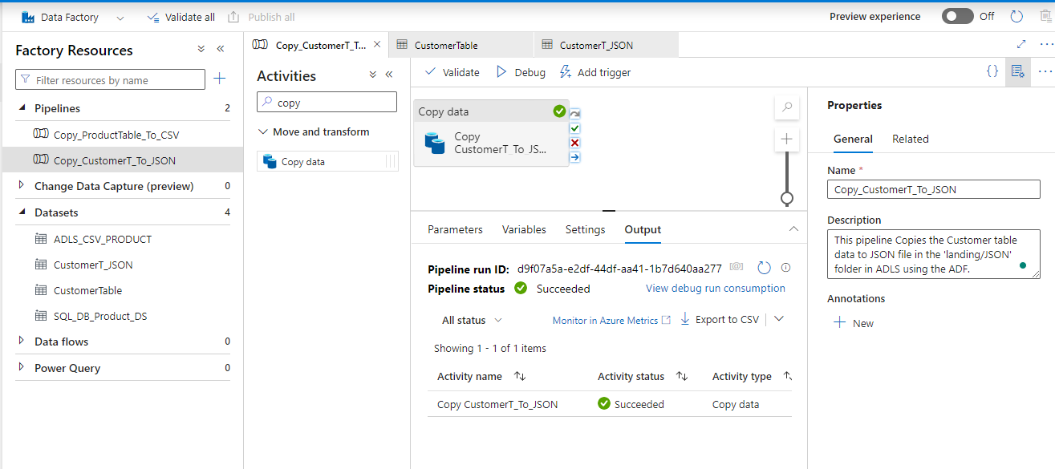

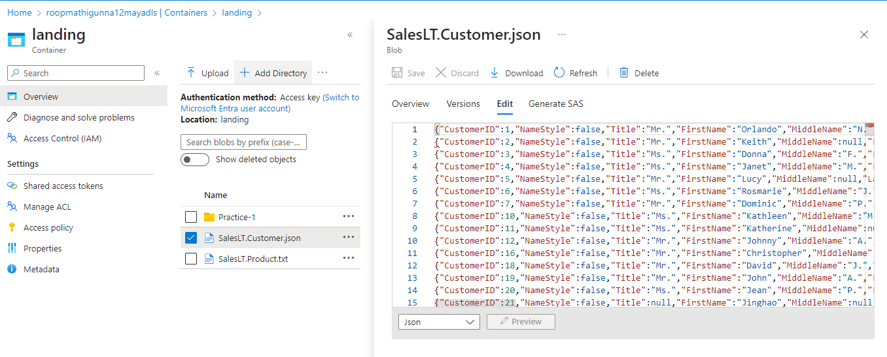

Pipeline 3: Create another pipeline name: Copy_Customer_JSON_To_Folder. In the last pipeline 1, you have created the Customer file in ADLS 'landing/CSV' folder. Now this time try to move this file to another ADLS folder 'landing/CSV2' using the ADF pipeline.

Hint: This time our source is ADLS 'landing/CSV' folder and destination is also of ADLS type but different folder 'landing/CSV2' (You can create one more dataset)

Source Selection :

Sink Mapping:

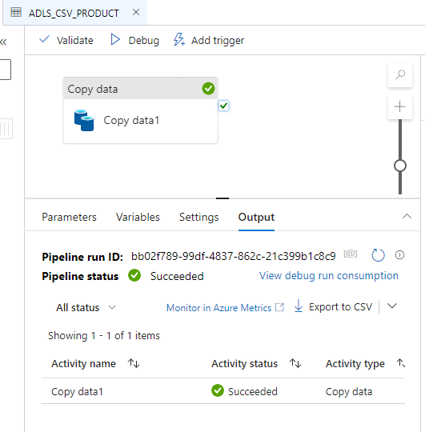

The Product_CSV is now copied into the Practice 1 Folder in ADLS account

Tough Question: Pipeline 4:

Create another pipeline name: Copy_Customer_To_CSV_Pipe In the newly created SQL DB there is one built in SalesLt.Customer table. Copy the Customer table data to CSV file in 'landing/CSV_Pipe' folder in ADLS using the ADF. But ensure that the delimiter of this file should be (|) instead of (,)

Here is the step I created the CSV Dataset that will be used as my sink. Selected Delimiter as Pipe |



